SIMATS ENGINEERING
ASSESSMENT TOOL 1

NAME: B. Sai Manoj Kumar
Reg No: 192411251
COURSE NAME: INTERNET PROGRAMMING
COURSE CODE: CSA4308

COURSE OUTCOME COVERED

CO-2 : Apply CSS layout and styling techniques to create visually appealing and responsive web interfaces, and use JavaScript to enable interactive client-side behavior. (L3)

Assessment Tool : Integrated Experiments

Weightage: 40%

QUESTIONS: Total Marks: 30

Experiment 1: Responsive Layout Design
Suppose that a retail website is not responsive across mobile and tablet devices, causing misalignment of content and improper spacing.
(a) Analyze the possible reasons for lack of responsiveness in the existing layout.
(b) Design a responsive webpage layout using CSS Flexbox or Grid, ensuring proper alignment of header, navigation, content, and footer.
(c) Demonstrate how the layout adapts to different screen sizes (mobile, tablet, desktop) using media queries.
(d) Implement spacing, alignment, and distribution techniques to improve visual consistency.
(e) Evaluate the effectiveness of the responsive design and suggest further improvements.

ANS:
(a) Analyze the possible reasons for lack of responsiveness
A retail website may fail to respond properly on mobile and tablet devices due to several design issues.
Possible reasons
- Fixed-width layouts using pixels instead of percentages.
- No viewport meta tag in the HTML page.
- Use of tables for page layout.
- Images with fixed dimensions.
- Navigation menu not optimized for small screens.
- Lack of CSS media queries.
- Improper use of margins and padding.
- Content containers not using Flexbox or Grid.
As a result, users experience horizontal scrolling, overlapping elements, misaligned text, and inconsistent spacing.
(b) Design a responsive webpage layout using CSS Flexbox
HTML
<!DOCTYPE html>
<html>
<head>
<meta charset="UTF-8">
<meta name="viewport" content="width=device-width, initial-scale=1.0">
<link rel="stylesheet" href="style.css">
<title>Retail Store</title>
</head>
<body>

<header>Retail Store</header>

<nav>
<a href="#">Home</a>
<a href="#">Products</a>
<a href="#">Offers</a>
<a href="#">Contact</a>
</nav>

<div class="container">
<aside class="sidebar">
Categories
</aside>

<main class="content">
<h2>Featured Products</h2>
<div class="products">
<div class="card">Product 1</div>
<div class="card">Product 2</div>
<div class="card">Product 3</div>
<div class="card">Product 4</div>
</div>
</main>
</div>

<footer>
© 2026 Retail Store
</footer>

</body>
</html>
CSS
*{
margin:0;
padding:0;
box-sizing:border-box;
}

body{
font-family:Arial, sans-serif;
display:flex;
flex-direction:column;
min-height:100vh;
}

header, footer{
background:#222;
color:white;
text-align:center;
padding:20px;
}

nav{
display:flex;
justify-content:center;
gap:20px;
background:#444;
padding:15px;
}

nav a{
color:white;
text-decoration:none;
}

.container{
display:flex;
flex:1;
gap:20px;
padding:20px;
}

.sidebar{
flex:1;
background:#f2f2f2;
padding:20px;
}

.content{
flex:3;
}

.products{
display:flex;
flex-wrap:wrap;
gap:20px;
}

.card{
flex:1 1 200px;
background:#e6e6e6;
padding:30px;
text-align:center;
border-radius:8px;
}
(c) Adapt the layout using media queries
/* Tablet */
@media (max-width:768px){

.container{
flex-direction:column;
}

nav{
flex-wrap:wrap;
}

.products{
justify-content:center;
}

}

/* Mobile */
@media (max-width:480px){

header{
font-size:24px;
}

nav{
flex-direction:column;
align-items:center;
}

.card{
flex:1 1 100%;
}

.container{
padding:10px;
}

}

OUTPUT:
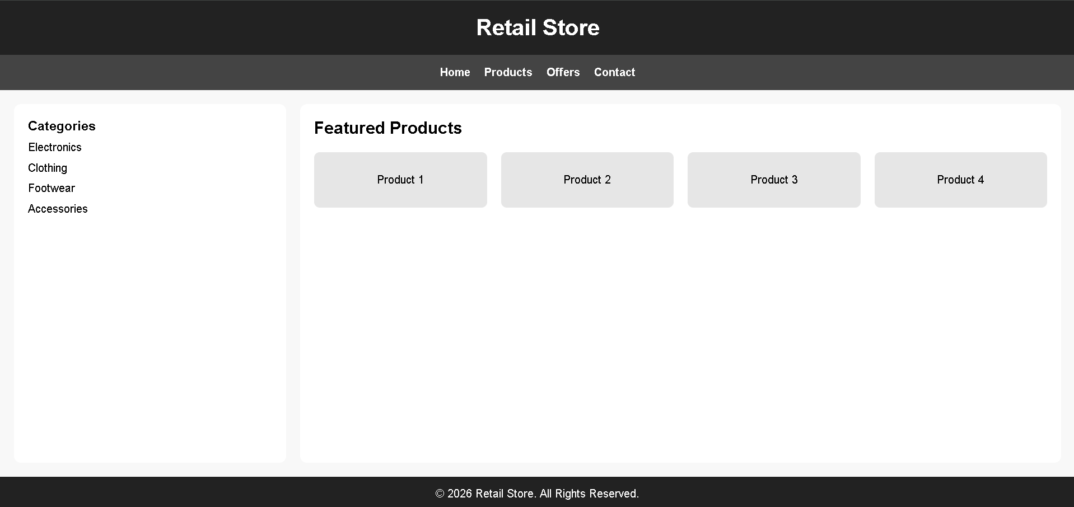

Layout behavior
Device | Layout
Desktop | Sidebar and content displayed side by side
Tablet | Sidebar moves above content, product cards wrap
Mobile | Navigation becomes vertical, cards occupy full width
(d) Implement spacing, alignment, and distribution techniques
Spacing
- padding: 20px for header, footer, sidebar, and content.
- gap: 20px between flex items.
- box-sizing: border-box for consistent sizing.
Alignment
- justify-content: center aligns navigation links.
- align-items: center centers mobile navigation.
- text-align: center improves readability.
Distribution
- flex: 1 distributes sidebar and content proportionally.
- flex-wrap: wrap allows product cards to move to new rows.
- flex: 1 1 200px creates responsive product cards.
These techniques maintain consistent spacing and alignment across different screen sizes.
(e) Evaluate the effectiveness of the responsive design
Advantages
- Works on mobile, tablet, and desktop devices.
- Eliminates horizontal scrolling.
- Maintains proper spacing and alignment.
- Flexible product grid improves readability.
- Easier to maintain using Flexbox.
Limitations
- Navigation could be improved with a hamburger menu.
- Product cards could use CSS Grid for better control.
- Images should use responsive sizing (max-width: 100%).
- Accessibility features can be enhanced.
Further improvements
- Use CSS Grid for complex product layouts.
- Add responsive images with srcset.
- Implement dark mode.
- Optimize fonts with relative units (rem).
- Improve accessibility using ARIA labels.
- Add smooth transitions and animations.

Result
A responsive retail webpage was designed using CSS Flexbox and media queries. The layout successfully adapts to mobile, tablet, and desktop screens, maintaining proper alignment, spacing, and visual consistency across different devices.

Experiment 2: Form Validation using JavaScript
Suppose that a registration form accepts invalid email and phone number inputs, leading to incorrect data submission.
(a) Analyze the issues in the existing form validation mechanism.
(b) Design input fields for email and phone number with appropriate HTML attributes.
(c) Implement JavaScript validation using Regular Expressions for both email and phone number.
(d) Develop a mechanism to display real-time error messages for invalid inputs.
(e) Evaluate the validation system and suggest enhancements for better user experience and security.

ANS:

Experiment 2: Form validation using JavaScript
(a) Analyze the issues in the existing form validation mechanism
The existing registration form allows invalid email addresses and phone numbers because it lacks proper validation.
Issues
- No validation for email format.
- Phone number accepts letters or special characters.
- Empty fields can be submitted.
- No real-time feedback.
- Users only discover errors after form submission.
- Invalid data may be stored in the database.
(b) Design input fields with HTML attributes
Use HTML5 validation attributes such as required, type="email", maxlength, and placeholder.
<!DOCTYPE html>
<html>
<head>
<meta charset="UTF-8">
<meta name="viewport" content="width=device-width, initial-scale=1.0">
<title>Registration Form Validation</title>

<style>

body{
font-family:Arial, sans-serif;
background:#f2f2f2;
display:flex;
justify-content:center;
align-items:center;
height:100vh;
}

.container{
background:white;
padding:30px;
width:350px;
border-radius:10px;
box-shadow:0 0 10px rgba(0,0,0,0.2);
}

h2{
text-align:center;
margin-bottom:20px;
}

input{
width:100%;
padding:10px;
margin-top:5px;
margin-bottom:5px;
border:1px solid #ccc;
border-radius:5px;
}

.error{
color:red;
font-size:14px;
margin-bottom:10px;
}

.success{
color:green;
text-align:center;
margin-top:10px;
}

button{
width:100%;
padding:10px;
background:#007bff;
color:white;
border:none;
border-radius:5px;
cursor:pointer;
}

button:hover{
background:#0056b3;
}

</style>

</head>

<body>

<div class="container">

<h2>Registration Form</h2>

<form id="registerForm">

<label>Email</label>
<input type="email"
id="email"
placeholder="Enter your email"
required>

<div id="emailError" class="error"></div>

<label>Phone Number</label>
<input type="text"
id="phone"
placeholder="Enter 10-digit phone number"
maxlength="10"
required>

<div id="phoneError" class="error"></div>

<button type="submit">Register</button>

<div id="successMessage" class="success"></div>

</form>

</div>

<script>

const email = document.getElementById("email");
const phone = document.getElementById("phone");

const emailError = document.getElementById("emailError");
const phoneError = document.getElementById("phoneError");
const successMessage = document.getElementById("successMessage");

const emailPattern = /^[^\\s@]+@[^\\s@]+\\.[^\\s@]+$/;
const phonePattern = /^[6-9]\\d{9}$/;

email.addEventListener("input", validateEmail);
phone.addEventListener("input", validatePhone);

function validateEmail(){

if(email.value === ""){
emailError.textContent = "Email is required";
return false;
}

if(!emailPattern.test(email.value)){
emailError.textContent = "Enter a valid email address";
return false;
}

emailError.textContent = "";
return true;

}

function validatePhone(){

if(phone.value === ""){
phoneError.textContent = "Phone number is required";
return false;
}

if(!phonePattern.test(phone.value)){
phoneError.textContent = "Enter a valid 10-digit phone number";
return false;
}

phoneError.textContent = "";
return true;

}

document.getElementById("registerForm").addEventListener("submit", function(event){

event.preventDefault();

const emailValid = validateEmail();
const phoneValid = validatePhone();

if(emailValid && phoneValid){

successMessage.textContent = "Registration successful!";

email.value = "";
phone.value = "";
}else{
successMessage.textContent = "";
}
});
</script>
</body>
</html>

OUTPUT:

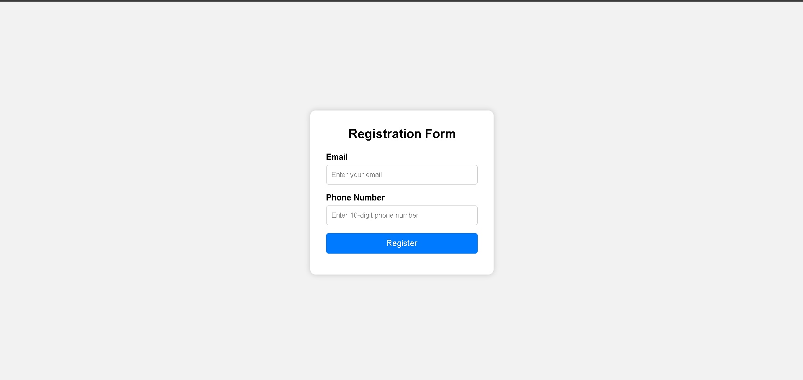
(c) Implement JavaScript validation using Regular Expressions
Email regex
const emailPattern = /^[^\\s@]+@[^\\s@]+\\.[^\\s@]+$/;
Checks that:
- text exists before @
- a valid domain exists
- a valid extension exists
Phone regex
const phonePattern = /^[6-9]\\d{9}$/;
Checks that:
- number starts with 6–9
- contains exactly 10 digits
(d) Real-time error message mechanism
Validation occurs while the user types using the input event.
email.addEventListener("input", validateEmail);
phone.addEventListener("input", validatePhone);
Example:
if(!emailPattern.test(email.value)){
emailError.textContent = "Enter a valid email address";
}
This immediately displays an error message without waiting for form submission.
(e) Evaluate the validation system
Advantages
- Prevents invalid email addresses.
- Prevents incorrect phone numbers.
- Gives immediate feedback.
- Reduces incorrect form submissions.
- Improves data quality.
Limitations
- Validation is only client-side.
- Users can bypass JavaScript.
- Regex cannot verify if an email actually exists.
Suggested enhancements
- Perform server-side validation.
- Use OTP verification for phone numbers.
- Use email verification links.
- Add password strength validation.
- Disable the submit button until all fields are valid.
- Sanitize inputs to prevent XSS attacks.
- Use HTTPS for secure data transmission.
Result
A registration form was developed with HTML5 input validation and JavaScript Regex validation. The system provides real-time error messages for email and phone number inputs, improving data accuracy, usability, and overall user experience.

Experiment 3: CSS Layout Debugging
Suppose that a webpage layout overlaps when the browser window is resized, affecting usability.
(a) Analyze the CSS properties responsible for layout overlapping issues.
(b) Examine the role of the CSS box model (margin, border, padding, content) in layout design.
(c) Debug the layout using appropriate positioning techniques (relative, absolute, flex, grid).
(d) Modify the CSS to ensure proper alignment and prevent overlapping during resizing.
(e) Evaluate the corrected layout and suggest best practices for maintaining consistency.

ANS:
Experiment 3: CSS layout debugging
(a) Analyze the CSS properties responsible for layout overlapping issues
Layout overlapping occurs when webpage elements are not properly positioned or sized. The main CSS properties responsible are:
- position: absolute removes elements from the normal document flow.
- Fixed width and height cause elements to overflow on smaller screens.
- Float-based layouts may overlap if not cleared properly.
- Improper z-index values can place elements on top of each other.
- Negative margins may pull elements into other sections.
- Lack of responsive units such as percentages, vw, vh, or Flexbox/Grid layouts.
These issues become more visible when the browser window is resized.
(b) Examine the role of the CSS box model
The CSS box model consists of four parts:
- Content: the actual text or image.
- Padding: space between the content and the border.
- Border: surrounds the padding and content.
- Margin: space outside the border.
Proper use of the box model ensures consistent spacing and prevents elements from touching or overlapping. Using box-sizing: border-box makes width and height calculations easier because padding and border are included in the specified dimensions.

CODE:
<!DOCTYPE html>
<html lang="en">
<head>
<meta charset="UTF-8">
<meta name="viewport" content="width=device-width, initial-scale=1.0">
<title>CSS Layout Debugging</title>
<link rel="stylesheet" href="style.css">
</head>
<body>

<header>
<h1>CSS Layout Debugging</h1>
</header>

<nav>
<a href="#">Home</a>
<a href="#">Services</a>
<a href="#">Products</a>
<a href="#">Contact</a>
</nav>

<div class="container">
<aside class="sidebar">
<h3>Sidebar</h3>
<p>Navigation and links</p>
</aside>

<main class="content">
<h2>Main Content</h2>
<div class="cards">
<div class="card">Card 1</div>
<div class="card">Card 2</div>
<div class="card">Card 3</div>
<div class="card">Card 4</div>
</div>
</main>
</div>

<footer>
&copy; 2026 CSS Layout Debugging
</footer>

</body>
</html>

CSS CODE:
*{
margin:0;
padding:0;
box-sizing:border-box;
}

body{
font-family:Arial, sans-serif;
background:#f2f2f2;
display:flex;
flex-direction:column;
min-height:100vh;
}

header{
background:#333;
color:white;
text-align:center;
padding:20px;
}

nav{
background:#555;
display:flex;
justify-content:center;
gap:20px;
padding:15px;
flex-wrap:wrap;
}

nav a{
color:white;
text-decoration:none;
}

.container{
display:flex;
flex:1;
gap:20px;
padding:20px;
}

.sidebar{
flex:1;
background:white;
padding:20px;
border:2px solid #ddd;
border-radius:10px;
}

.content{
flex:3;
background:white;
padding:20px;
border:2px solid #ddd;
border-radius:10px;
}

.cards{
display:flex;
flex-wrap:wrap;
gap:20px;
margin-top:20px;
}

.card{
flex:1 1 200px;
background:#e6e6e6;
padding:40px;
text-align:center;
border-radius:8px;
}

footer{
background:#333;
color:white;
text-align:center;
padding:15px;
}

/* Tablet layout */
@media (max-width:768px){

.container{
flex-direction:column;
}

.sidebar,
.content{
width:100%;
}
}

/* Mobile layout */
@media (max-width:480px){

nav{
flex-direction:column;
align-items:center;
}

.cards{
flex-direction:column;
}

.card{
width:100%;
}

.container{
padding:10px;
}

header h1{
font-size:24px;
}
}
OUTPUT:
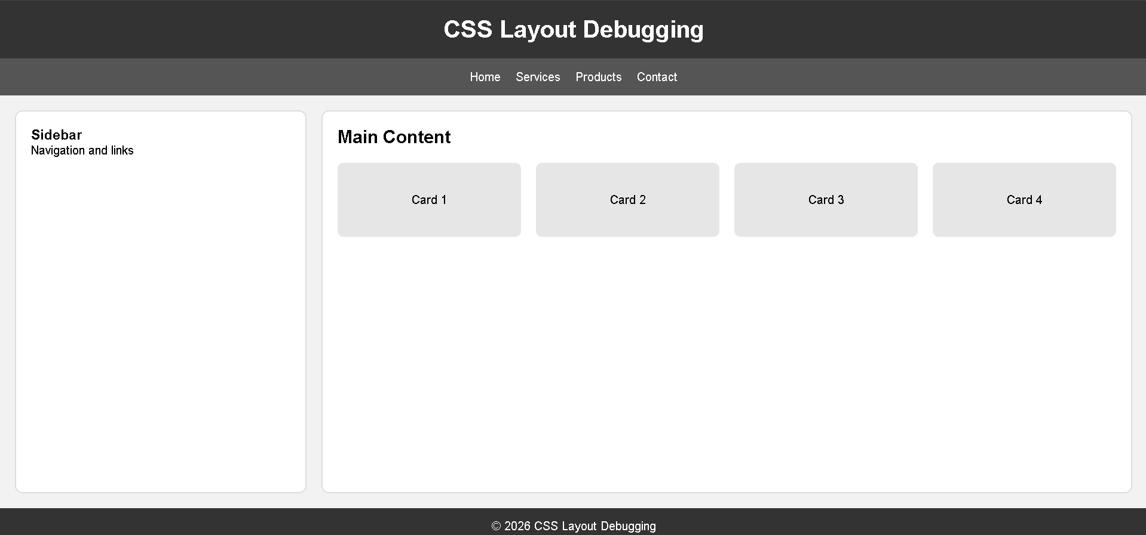
(c) Debug the layout using appropriate positioning techniques
To fix overlapping, modern layout methods should be used.
- Relative positioning keeps elements in the normal flow while allowing adjustments.
- Absolute positioning should be used only for small decorative elements.
- Flexbox is suitable for one-dimensional layouts such as rows or columns.
- CSS Grid is suitable for complex two-dimensional layouts.
For responsive webpages, Flexbox or Grid is preferred because elements automatically adjust according to screen size.
(d) Modify the CSS to ensure proper alignment and prevent overlapping
The following improvements can be applied:
- Use display: flex for layout containers.
- Apply flex-wrap: wrap to allow items to move to the next line.
- Replace fixed widths with flexible units.
- Add gap for spacing between elements.
- Use box-sizing: border-box.
- Apply media queries to change the layout for tablets and mobile devices.
- Avoid unnecessary absolute positioning.
These changes maintain proper alignment and spacing during browser resizing.
(e) Evaluate the corrected layout and suggest best practices
Evaluation
The corrected layout provides:
- No overlapping during resizing.
- Proper alignment of sidebar and content.
- Flexible spacing between elements.
- Better readability on mobile, tablet, and desktop devices.
Best practices
- Use Flexbox or Grid instead of float layouts.
- Apply box-sizing: border-box globally.
- Use relative units such as %, rem, and vw.
- Test layouts on multiple screen sizes.
- Keep margins and padding consistent.
- Minimize the use of absolute positioning.
- Use media queries for responsive behavior.
Result
The webpage layout was successfully debugged using Flexbox, proper box model implementation, and media queries. The corrected layout prevents overlapping, maintains consistent spacing, and adapts effectively to different screen sizes.
This is the theory answer. After this, you can write the HTML and CSS code implementation.

Code of Conduct:

I B. Sai Manoj Kumar (192411251) (Name / Reg No) certify that this submission is my original work and that I have adhered to the guidelines specified for this assessment. I understand that any violation of academic integrity rules will result in disciplinary action.

Signature of the student: B. Sai Manoj Kumar

RUBRICS FOR CALCULATION:

Criteria | Weightage | Level 4 – Exemplary | Level 3 – Proficient | Level 2 – Developing | Level 1 – Beginning
Understanding of Concepts | 25 | Demonstrates thorough understanding and effectively integrates multiple concepts/technologies | Good understanding with proper integration of most concepts | Basic understanding; limited or partial integration | Poor understanding; unable to integrate concepts
Experimental Design | 30 | Well-planned, systematic implementation with optimal solution | Correct implementation with minor issues | Basic implementation with errors or inefficiencies | Incorrect or incomplete implementation
Use of Tools | 20 | Effective and advanced use of tools/technologies with proper configuration | Appropriate use of tools with correct execution | Limited or inconsistent use of tools | Incorrect or minimal use of tools
Analysis of Results | 15 | Insightful analysis with accurate interpretation and validation of results | Good analysis with reasonable interpretation | Basic analysis with limited insights | Poor or incorrect analysis of results
Documentation | 10 | Clear, well-structured documentation with diagrams, code, and results | Organized documentation with necessary details | Basic documentation with missing details | Poor or incomplete documentation

